Mechanics: for Rigid body
1. Newton’s second law for rotation
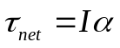
(1) torque vector 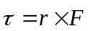 (the torque about a point)
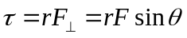 (torque about a fixed axis)
(2)Moments of inertia (rotational inertia)
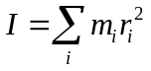 (system of particles)
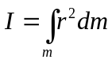 (continuous rigid body)
(3) parallel-axis theorem
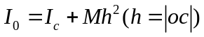
long uniform rod of length L and mass M.
(a)The axis is through center 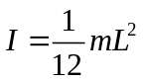
(b) The axis through the end 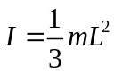
Uniform thin hoop of radius R and mass M 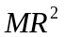
Uniform solid cylinder of radius R and mass M 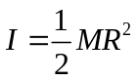
2 Angular Momentum and its conservation
(1)Angular Momentum
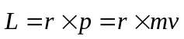 (Angular momentum of a particle about point O）
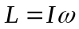 (rigid body)
(2)Angular momentum theorem
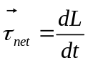 (for particle)
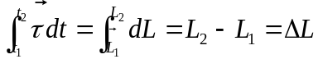
The time rate of change of angular momentum of a particle is equal to the net torque applied to it.

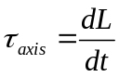 (for rigid body)

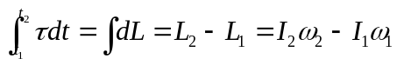
The time rate of change of the total angular momentum of a system of particles equals external torque on the system

(3) Conservation of angular momentum
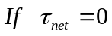, 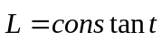 ( for particle)
， 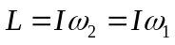 (for rigid body）
If total angular momentum of a rotating body remains constant if the net external torque acting on it is zero.
3 work and energy
(1) Rotational kinetic Energy
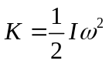
(2) The work done by torque acting on a rigid body rotating about a fixed axis
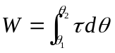
(3) Work-energy principle for fixed-axis rotation
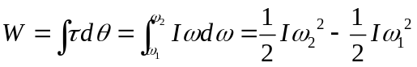
(4) Gravitational potential energy
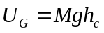
(5) Law of conservation of mechanical energy

